Q: | Are contractors/subcontractors required to pay prevailing wages for all public works projects?
A: | Any contract that is over $1,000 is subject to the payment of prevailing wages (Labor Code 1771). This dollar amount pertains to the overall project value. Not the subcontractor’s portion of the project value.
Q: | Who must be paid prevailing wages on public works projects?
A: | Prevailing wages must be paid to ALL “workers” on public works projects, including owners/partners who perform work.
Q: | Are contractors/subcontractor required to submit electronic certified payroll reports (eCPR) to the Department of Industrial Relations (DIR) on San Diego Unified School District projects that are under the Project Stabilization Agreement (PSA)?
A: | Yes. Electronic certified payroll reports (eCPR’s) must be submitted to DIR on all San Diego Unified School District projects. Regardless, if the project is under the PSA or not.
 | The following exemptions from submitting eCPR’s are for projects valued at or less than.
 | • *$25,000 for new construction, alteration, installation, demolition or repair
 | • *$15,000 for maintenance
 | * Payment of prevailing wages is still required.
Q: | Are contractors/subcontractors required to submit certified payroll reports, and other related documentation to San Diego Unified School District?
A: | No. However, the District reserves the right to request certified payroll reports, and other related documentation upon request.
Q. | How do you determine which general wage determination applies?
A. | The bid advertisement date.
Q. | What are the effective dates for wage determinations?
A. | General wage determinations are issued twice a year. The first wage determination goes into effect on March 3rd in a leap year and March 4th in a non-leap year. The second wage determination goes into effect on September 1st.
 | Guide to applicability of wage determinations:
 | ~From March 3rd or 4th (depending if leap year or not ) - August 31st the 20XX-1 wage determination applies
 | ~From September 1st - March 2nd or March 3rd (depending if leap year or not) the 20XX-2 wage determination applies
Q: | What does it mean when there is a single asterisk (*) on a prevailing wage determination?
A: | Prevailing wage determinations with a single asterisk (*) are in effect for the life of the project. No predetermine increases.
Q: | What does it mean when there are double asterisk (**) on a prevailing wage determination?
A: | Prevailing wage determinations with double asterisk (**) indicate that the rate of pay and/or fringes have predetermine increases. If work is to extend past the date of the last predetermine increase, there will be no further increases and the rate will be paid for the life of the project.
Q: | What does a (#) symbol mean on a DIR wage determination?
A: | This indicates that the craft/trade is apprenticeable, and apprentices must be hired.
 | • FAQ – Prevailing Wage
 | Office of the Director - Research: Frequently Asked Questions - Prevailing Wage (ca.gov)
 | • FAQ – Public Works Information
 | Division of Apprenticeship Standards - Home Page (ca.gov)
Q: | Can a contractor be given credit for union dues under the fringe benefits (employer payments)?
A: | It depends on the craft/trade. Must refer to the applicable DIR wage determination and see if union dues are included in the employer payments.
Q: | Does the District give credit for prevailing wage increases per the Collective Bargaining Agreement (CBA)?
A: | No. The District will ONLY pay for the predetermine increases, as stated in the applicable DIR wage determination. No more. No less. Furthermore, the PSA is very specific as to this matter (see below).
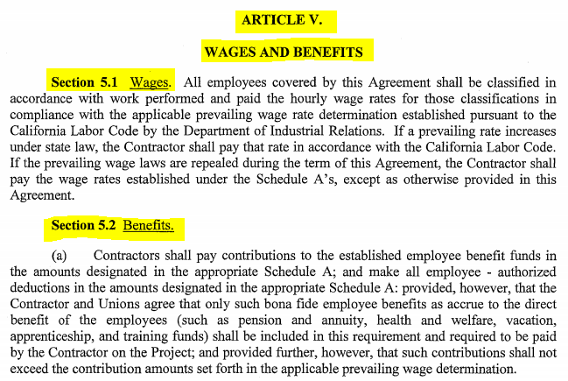
Q: | Are all fringes taxed?
A: | No. Fringes paid to a bona fide third-party approved plan (i.e. pension, medical insurance, vision & dental) are not taxed. The ONLY fringes that are taxed, are those paid and added to the worker’s hourly rate of pay.
Q: | When does overtime apply?
A: | Compensation for all hours worked in excess of eight hours per day and 40 hours during one week should be not less than one-and-one-half times he basic rate of pay. For specific overtime requirements, please refer to the craft/trade’s applicable wage determination.
Q: | When is travel & subsistence applicable?
A: | Depends on the craft/trade. You must refer to the DIR wage determination to determine if travel & subsistence is an approved allowance for the stated craft/trade.
Q: | Are the same prevailing wages paid on allowances?
A: | Yes. The applicable DIR wage determination is for the life of the project. This includes amendments, allowances, change orders, warranty work, and work related under the contract number.
Q: | Does the District pay foreman rates?
A: | No. The Department of Industrial Relations does not provide foreman rates. Therefore, the District will not pay for them.
Q: | Does prevailing wage apply to LLB and D/B contracts, to include design and preconstruction work?
A: | Yes. Design, site assessment, feasibility study, and other preconstruction phases of construction, including, but not limited to, inspection and land surveying work, regardless of whether any further construction work is conducted, and work performed during the postconstruction phases of construction, including, but not limited to, all cleanup work at the jobsite (see Labor Code 1720).
For further labor compliance/prevailing wage questions, please direct them to either:
Graham Champion
Labor Compliance and Construction Contracts Supervisor
gchampion@sandi.net
Carmen Peralta
Senior Contract Specialist
cperalta1@sandi.net

